**WEEK 01**

1. ***Create a Scenario based ER-Models with the entities. (Hospital Details like: Wards, Patients, Doctor, Bills etc). Convert this ER-model into table with all the entities. (Minimum five Entities).***

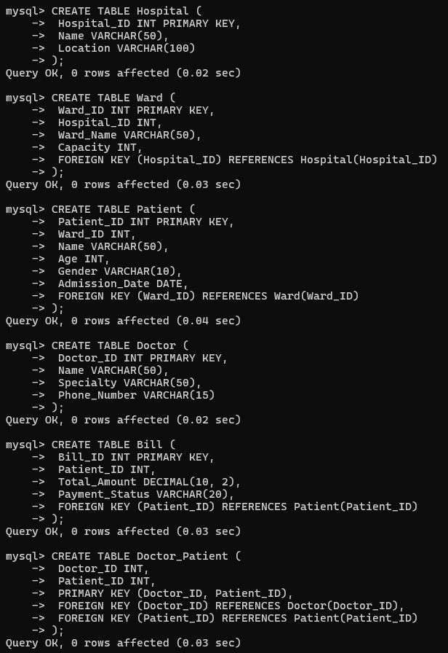

1. ***Insert random data in each column of all the tables***

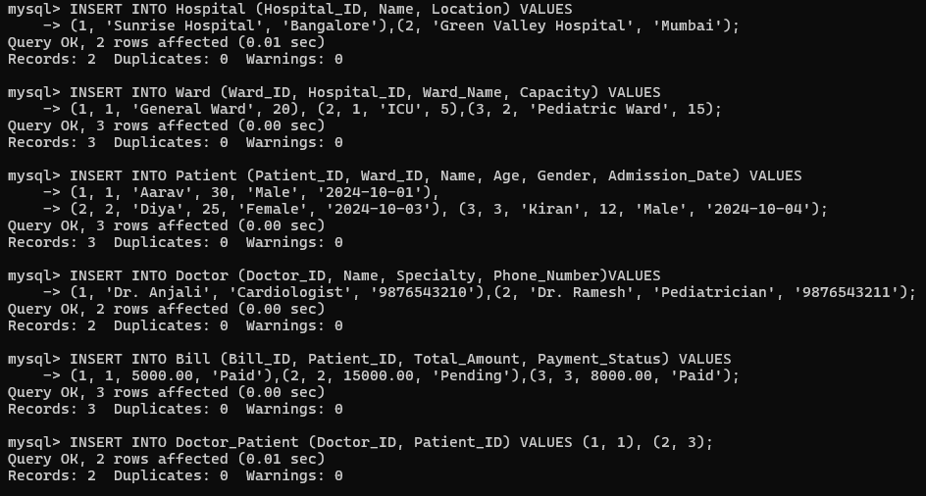

1. ***Update the table by applying some conditions.(For example: using alter command)***

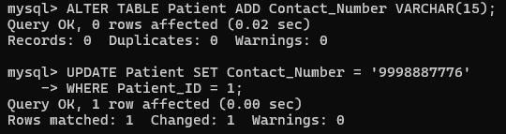

1. ***Apply the `DELETE` and `DROP` command, and then review the results.***

DELETE FROM bill WHERE Patient_ID = 2;

DROP TABLE Doctor_Patient;

